

# PETBOT

**Supervisor:** *NGUYỄN HẠ VY*

**Semester:** *01*

**Batch No:** *T1.2208.A2*

**Group No:** *03*

|  |  |  |
| --- | --- | --- |
| **Order:** | **Full name** | **Roll No.** |
| *1.* | *HÀ THANH PHONG* | Student1409675 |
| *2.* | *DIỆP CẨM LY* | Student1408003 |
| *3.* | *VƯƠNG YẾN NHI* | Student1408025 |
| *4.* | *TRƯƠNG NGỌC TỨC* | Student1409129 |

***Month****: 11* ***Year****: 2022*



This is to certify that

**Mr. HÀ THANH PHONG Mr. DIỆP CẨM LY Mr. VƯƠNG YẾN NHI**

**Mr. TRƯƠNG NGỌC TỨC**

Have successfully Designed & Developed

# PETBOT

Submitted by:

**Ms. NGUYEN HA VY**

Date Of Issue:

Authorized Signature:

# Content

1. Content
2. Acknowledgements
3. Synopsis
4. Review 1
5. Review 2
6. Review 3
7. Task Sheet

# Acknowledge

As we understand that the eProject is a step-by-step learning environment that closely simulates the classroom and Lab-based learning environment into actual implementation. It is a project implementation at your fingertips!! An electronic, live juncture on the machine that allows you to.

* Practice step by step i.e. laddered approach.
* Build a larger more robust application.
* Usage of certain utilities in applications designed by user.
* Single program to unified code leading to a complete application.
* Learn implementation of concepts in a phased manner.
* Enhance skills and add value.
* Work on real-life projects.
* Give a real-life scenario and help to create applications that are more complicated and useful.
* Mentoring through email support.

First of all, I would like to thank India Aptech for allowing my team to work on this fantastic eProject. We had a great experience with eProject this time.

Next, We would like to express my special thanks to our mentor, Ms. Ha Vy for the time and effort that she provided throughout the project. Your helpful advice and suggestions were beneficial to us during the completion of the project. In this respect, We are forever grateful to you.

Besides several mistakes we made in the project, we hope to have more opportunities to widen our knowledge in the web-developing world.

We will try to continue to learn and improve ourselves even more in the future.

Yours Sincerely, Team Group 03.

# Synopsis

The Objective of this program we aim is to give a sample project to work on real- life projects. These applications help us build a larger more robust application.

The objective is not to teach us HTML/JavaScript but to provide us with a real-life scenario and help us create basic applications using the tools.

Hence, we can revise the chapters before we start with the project.

This project is meant for students like us who have completed the module of HTML5. These programs should be done in the Lab sessions with the assistance of the faculty if required.

The website (in this project) is a tool that brings everything in the world to you such as historic monuments information natural knowledge and skill in technology...

It is very essential for us that will have a clear understanding of the subject. We think we should go through the project and solve the assignments as per the requirements given.

And get back [***eprojects@aptech.ac.in***](mailto:eprojects@aptech.ac.in) as the assigned schedule.

## Problem Definition

**PETBot company**, are one of the eminent business entities engaged in

manufacturing, supplying and exporting a wide range of PET/PP/PC Bottles. The

company has state of the art manufacturing unit of PET bottles.

They have PET Bottles making Plant. Available in customized form, their machines

are used by several manufacturing companies in making of packaged drinking water,

household chemicals, pharmaceuticals, edible oils, liquor, hare care, pesticide etc.

The website is to be developed for the Windows Platform using HTML5, JavaScript

and Geolocation. The site should work well in all leading browsers including Chrome,

IE, Firefox etc.

**Requirement Specification:**

The Web site is to be created based on the following requirements.

1) The Home Page should be created making use of Sections with a suitable

logo, the header section can be added which will show images of various

bottles.

2) The site must contain the links to navigate through any category for the

information.

3) Links of bottles can be categorized like (Bottles, Jars, etc.)

4) Specification and Pricing of Bottles can be added along with the images.

5) Gallery section can be added for viewing different images.

6) Feedback must be allowed to enter by the viewer

7) Site map, Gallery, about us, Queries link must be added.

8) The complete description must be allowed to get download as pdf or doc file.

9) The advertise section with various facilities provided should be mentioned.

10) There should be a “Contact Us” page which will have the Address of the

Company which is as follows and the mail address which when clicked will

invoke the local mail client from where they can send an email. Address of the

Company should be displayed using GeoLocation API (eg. GoogleMaps).

## Customer Requirements Specifications

### User:

#### input:

* Data of registered members.
* Feedback to the webmaster.

#### Process:

* Check the data of registered members.
* Check the feedback of users.

#### Output:

* Confirm the data of registered members.
* Confirm the feedback of the users.

### Hardware/ software requirement:

#### Software:

* + Notepad/HTML editor
  + Dreamweaver
  + IE 5.0/ Netscape 6.0

#### Hardware:

* + A minimum computer system that will help you access all the tools in the courses is a Pentium 166 or better
  + 64 Megabytes of RAM or better

|  |  |
| --- | --- |
| **Document Name**:  Architecture and design of the project | **SWD/Form** No.03/ARD/Ver1.0 |
| **Version** 1.0 | **Page 3** |

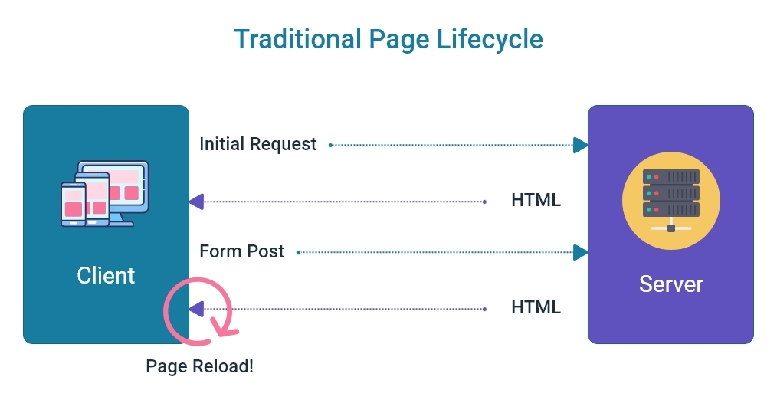

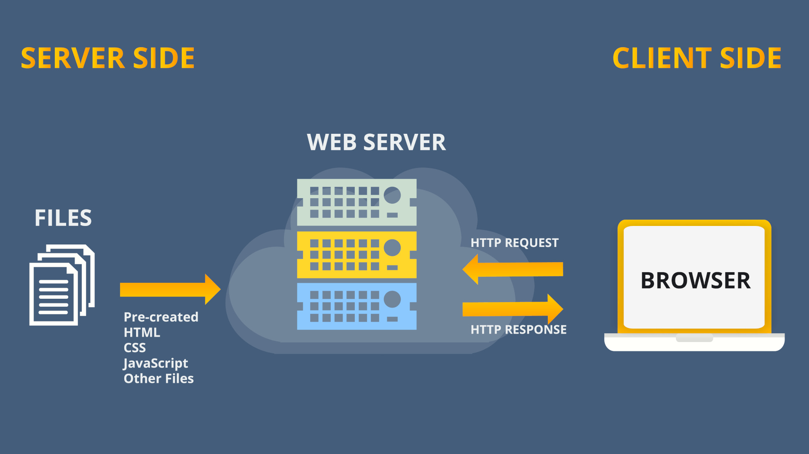

SITE MAP

Register

Login

Blog Details

Product Details

Company information

Login/Register

Blogs

Feedback

Home

Products

About us

Contact us

Add to cart

# Screenshots

# I.Homepage

**Description Homepage:**

1. Homepage

* Navbar (home, products, about us, contact us, feedback, blogs) with logo.
* Slideshow product
* Introduction
* Recent products
* What is PET plastic?
* Frequently asked questions

Screenshot about them:



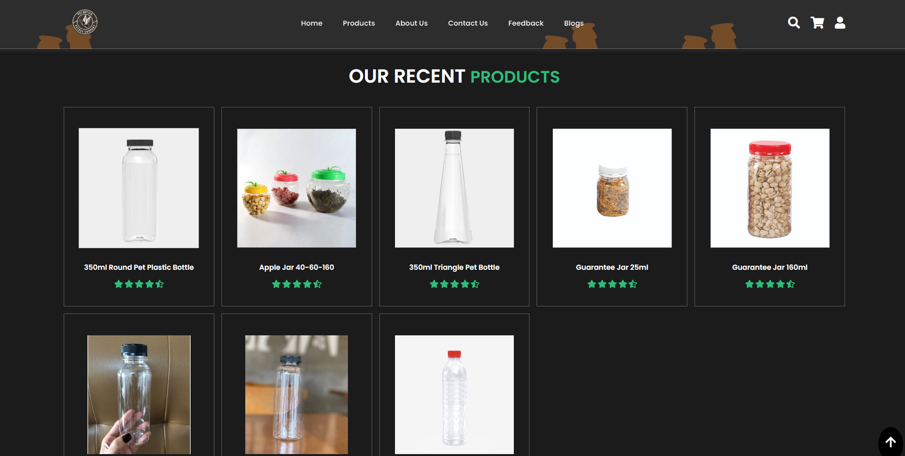

**Interactive with web at Homepage**

# II.Products

**Description:**

***Catergories have :***

+All items that store is selling.

***Some image about Categories page***

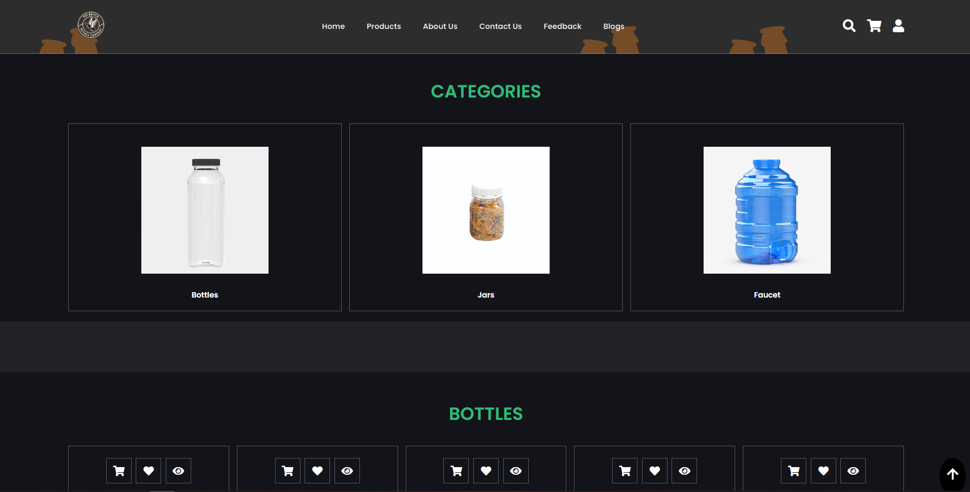

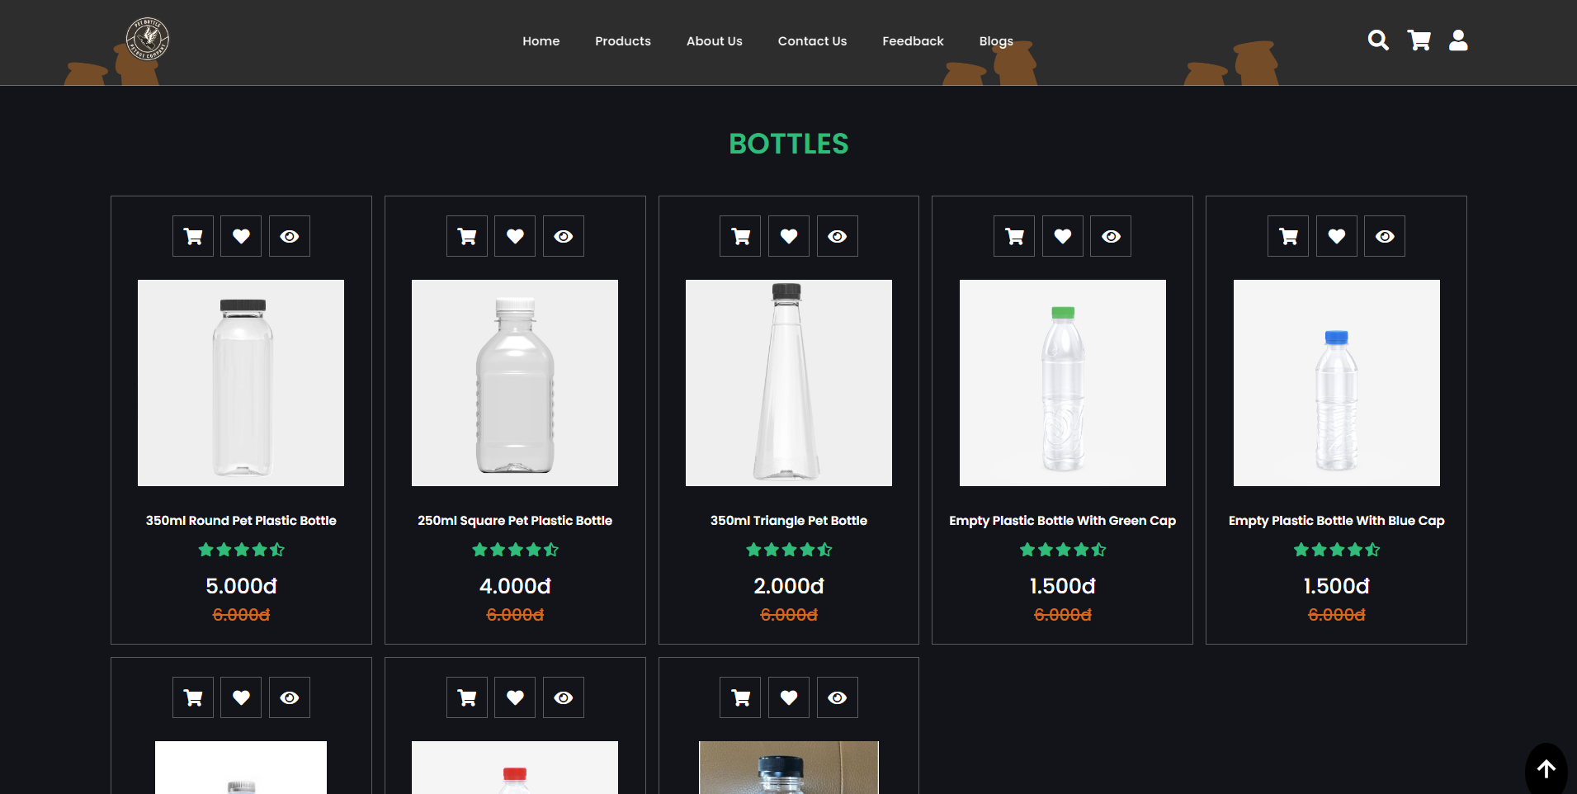

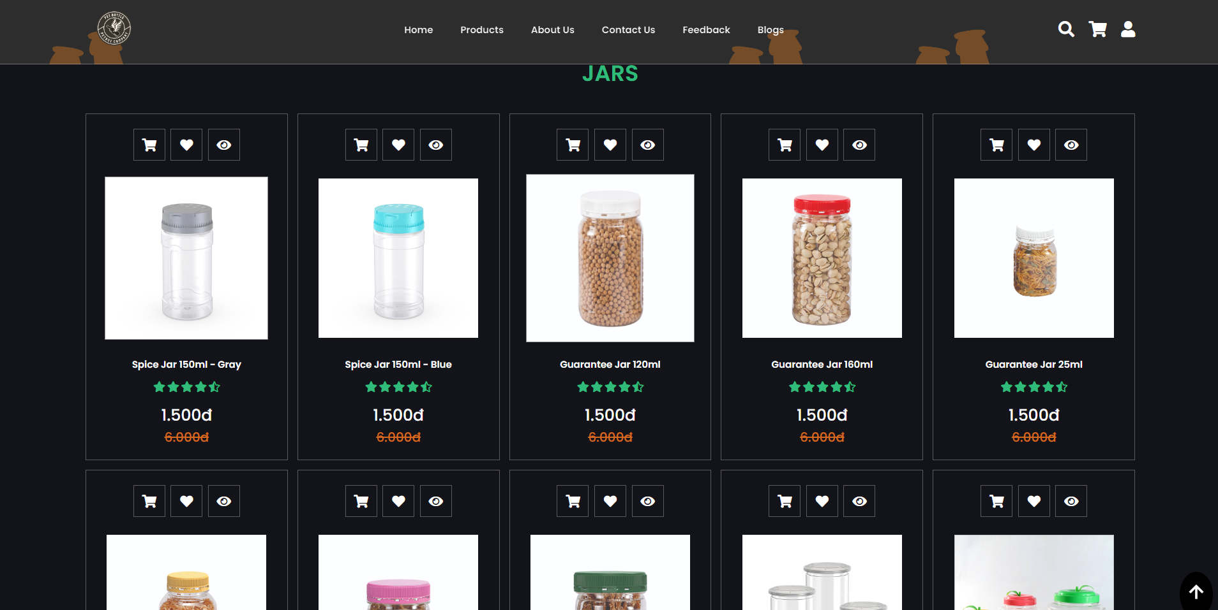

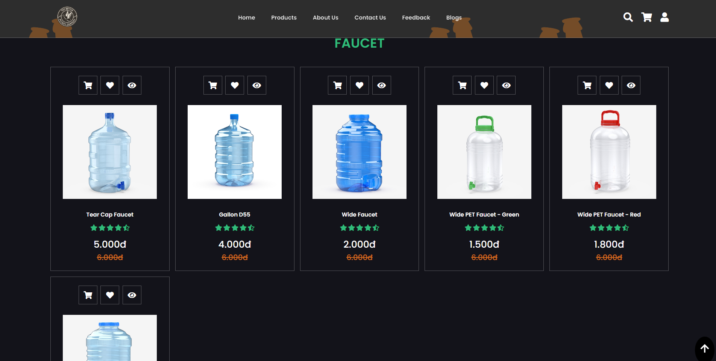

User can add or delete any items.

Click “shopping-cart” to add to cart.

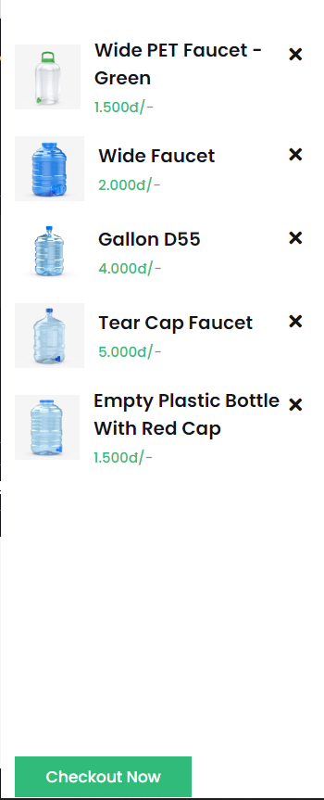

Click “X” icon to delete item.

# III.About us:

**About us page have:**

+ Our story, our misson and a little information about stores:

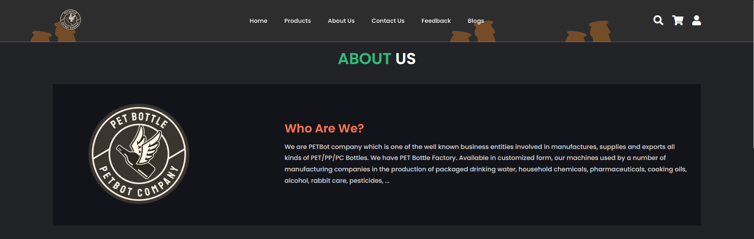

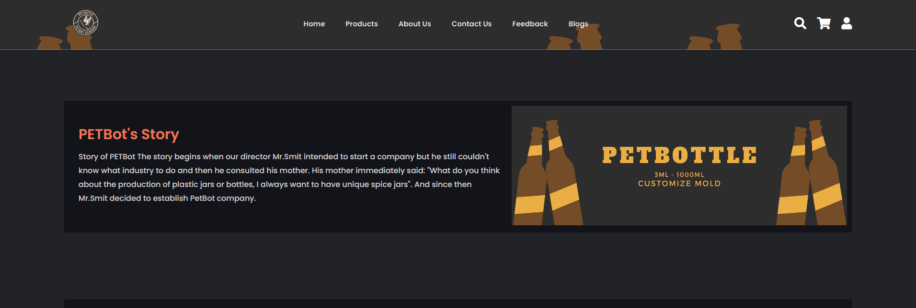

# IV.Contact Us:

Contact page about:

+Form that you can use contact with company.

+Location of store.

# V.Register/Sign-in form:

When you hover icon user, it will be showed

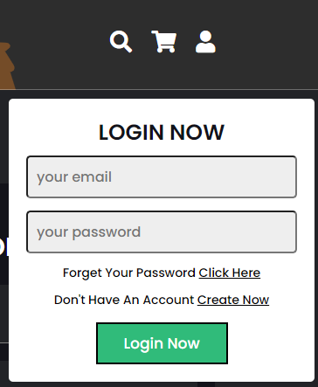

If you choose “Create Now”, this form will appear:

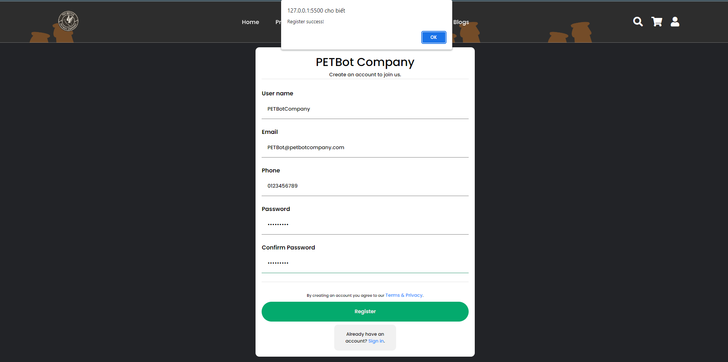

# VI.FEEDBACK:

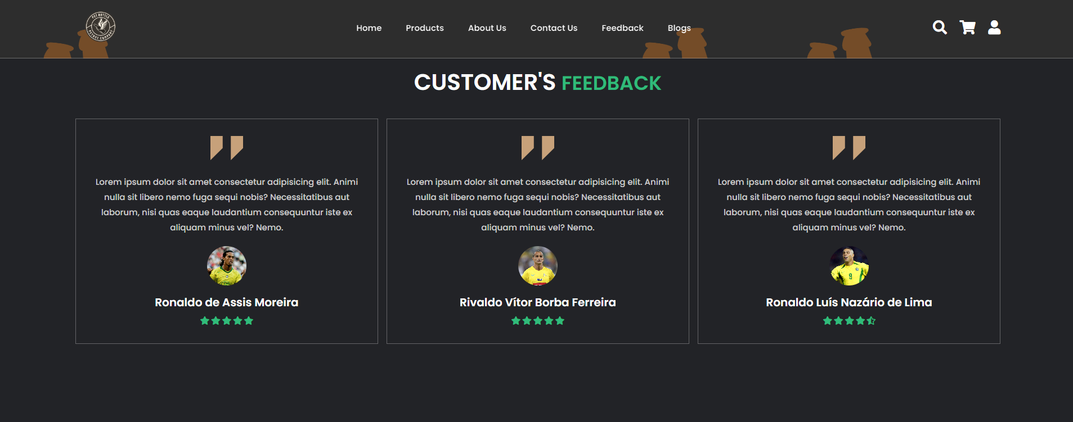

# VII.BLOGS:

# 

Task sheet

